Tournament: Nov. 1 - Nov. 3, 2018

Coach’s Registration Booklet
All Registrations Must Be Submitted
by 3:00 pm
Tues. Oct. 23, 2018

2018 A Boys Soccer Championships

School:

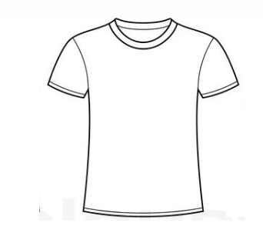
Coach:
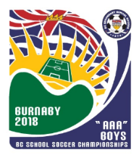
Size | Number of Shirts | Cost  $20 / shirt
Small | . . | . .
Medium | . . | . .
Large | . . | . .
X Large | . . | . .
XXL | . . | . .

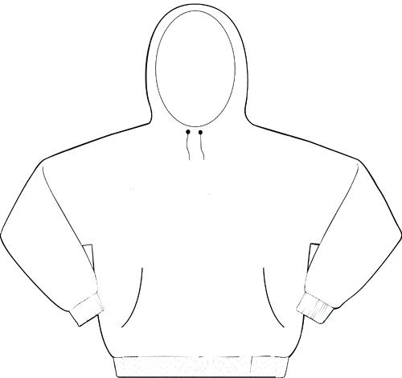
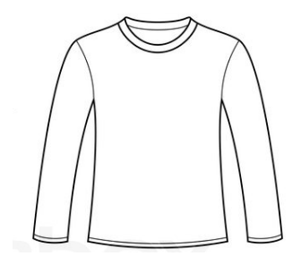
Size | Number of Shirts | Cost  $25 / shirt
Small | . . | . .
Medium | . . | . .
Large | . . | . .
X Large | . . | . .
XXL | . . | . .

Size | Number of Shirts | Cost  $32 / shirt
Small | . . | . .
Medium | . . | . .
Large | . . | . .
X Large | . . | . .
XXL | . . | . .

2018 BC Boys ‘A’ Soccer
Provincial Championship Clothing & Registration form
495 Beech Avenue Duncan B.C. V9L 3J8
ph: (250) 746-3654 (ext. 2120)
cell: 250-510-7311
For provincial website go to www.soccer2018.ca/

School name: __________________________________________

Contact person: _________________________________________

Contact phone number: _____________________

Contact email: ________________________________________

Tournament Fee: $485
Banquet tickets: _____ x $25 = $______

Team picture (8x10): $12 each x ____ = $ ______

Program $2.00 each x ____ = $______

Attitude Pictures (8x20): $25 each x _____ = $______

T-shirt costs: $ ______

Long sleeves: $ ______

Hoodies costs: $ ______

Total amount: $_______
Please print this form out and fill it in and then scan it back to tveenstra@duncanchristian.com Thanks!

Team Roster Information
(For the Tournament Program)

Team Name:____________________________________________
Athletic Zone: _________________________________________
 | Jersey Number | Name | Position | Grade | Height  (ft, inches)
1.
2.
3.
4.
5.
6.
7.
8.
9.
10.
11.
12.
13.
14.
15.
16.
17.
18.
19.
20.
21.
22.
23.
24.
25.

Coach: _____________________________

Asst Coach: ____________________________

Manager: _____________________________

Team Picture
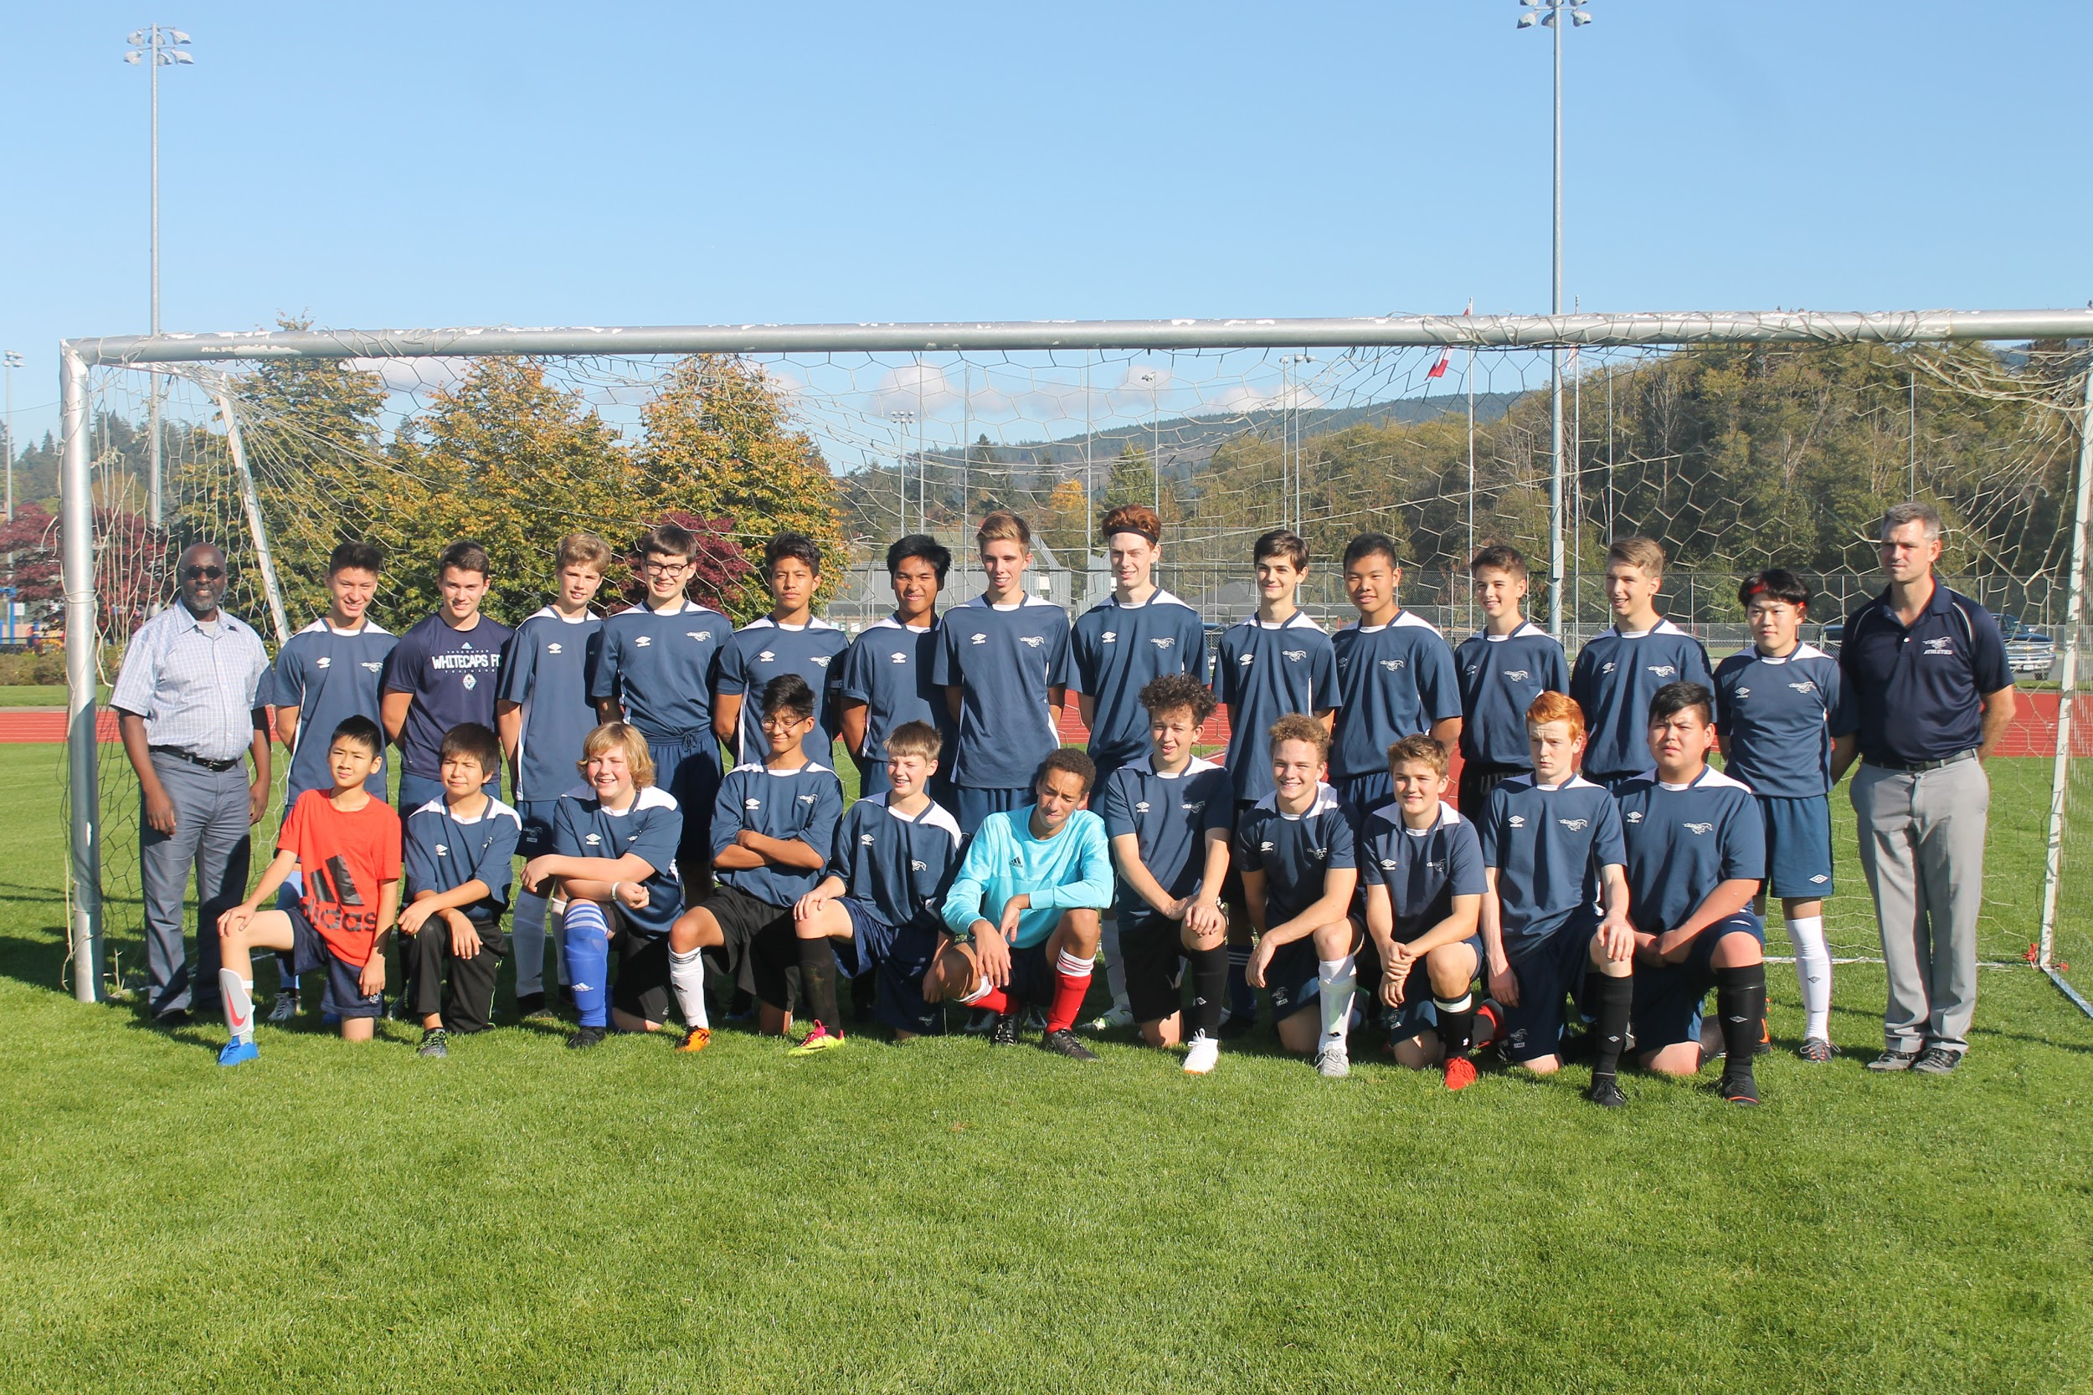

Please email your team photo, roster, and your athletic logo
tveenstra@duncanchristian.com
by 3:00 pm October 23rd at the latest.

We must have your team picture emailed to us for the tournament programs and other related purposes. Make it about a 700kb digital image 6” x 4” and try to have your players’ numbers showing.

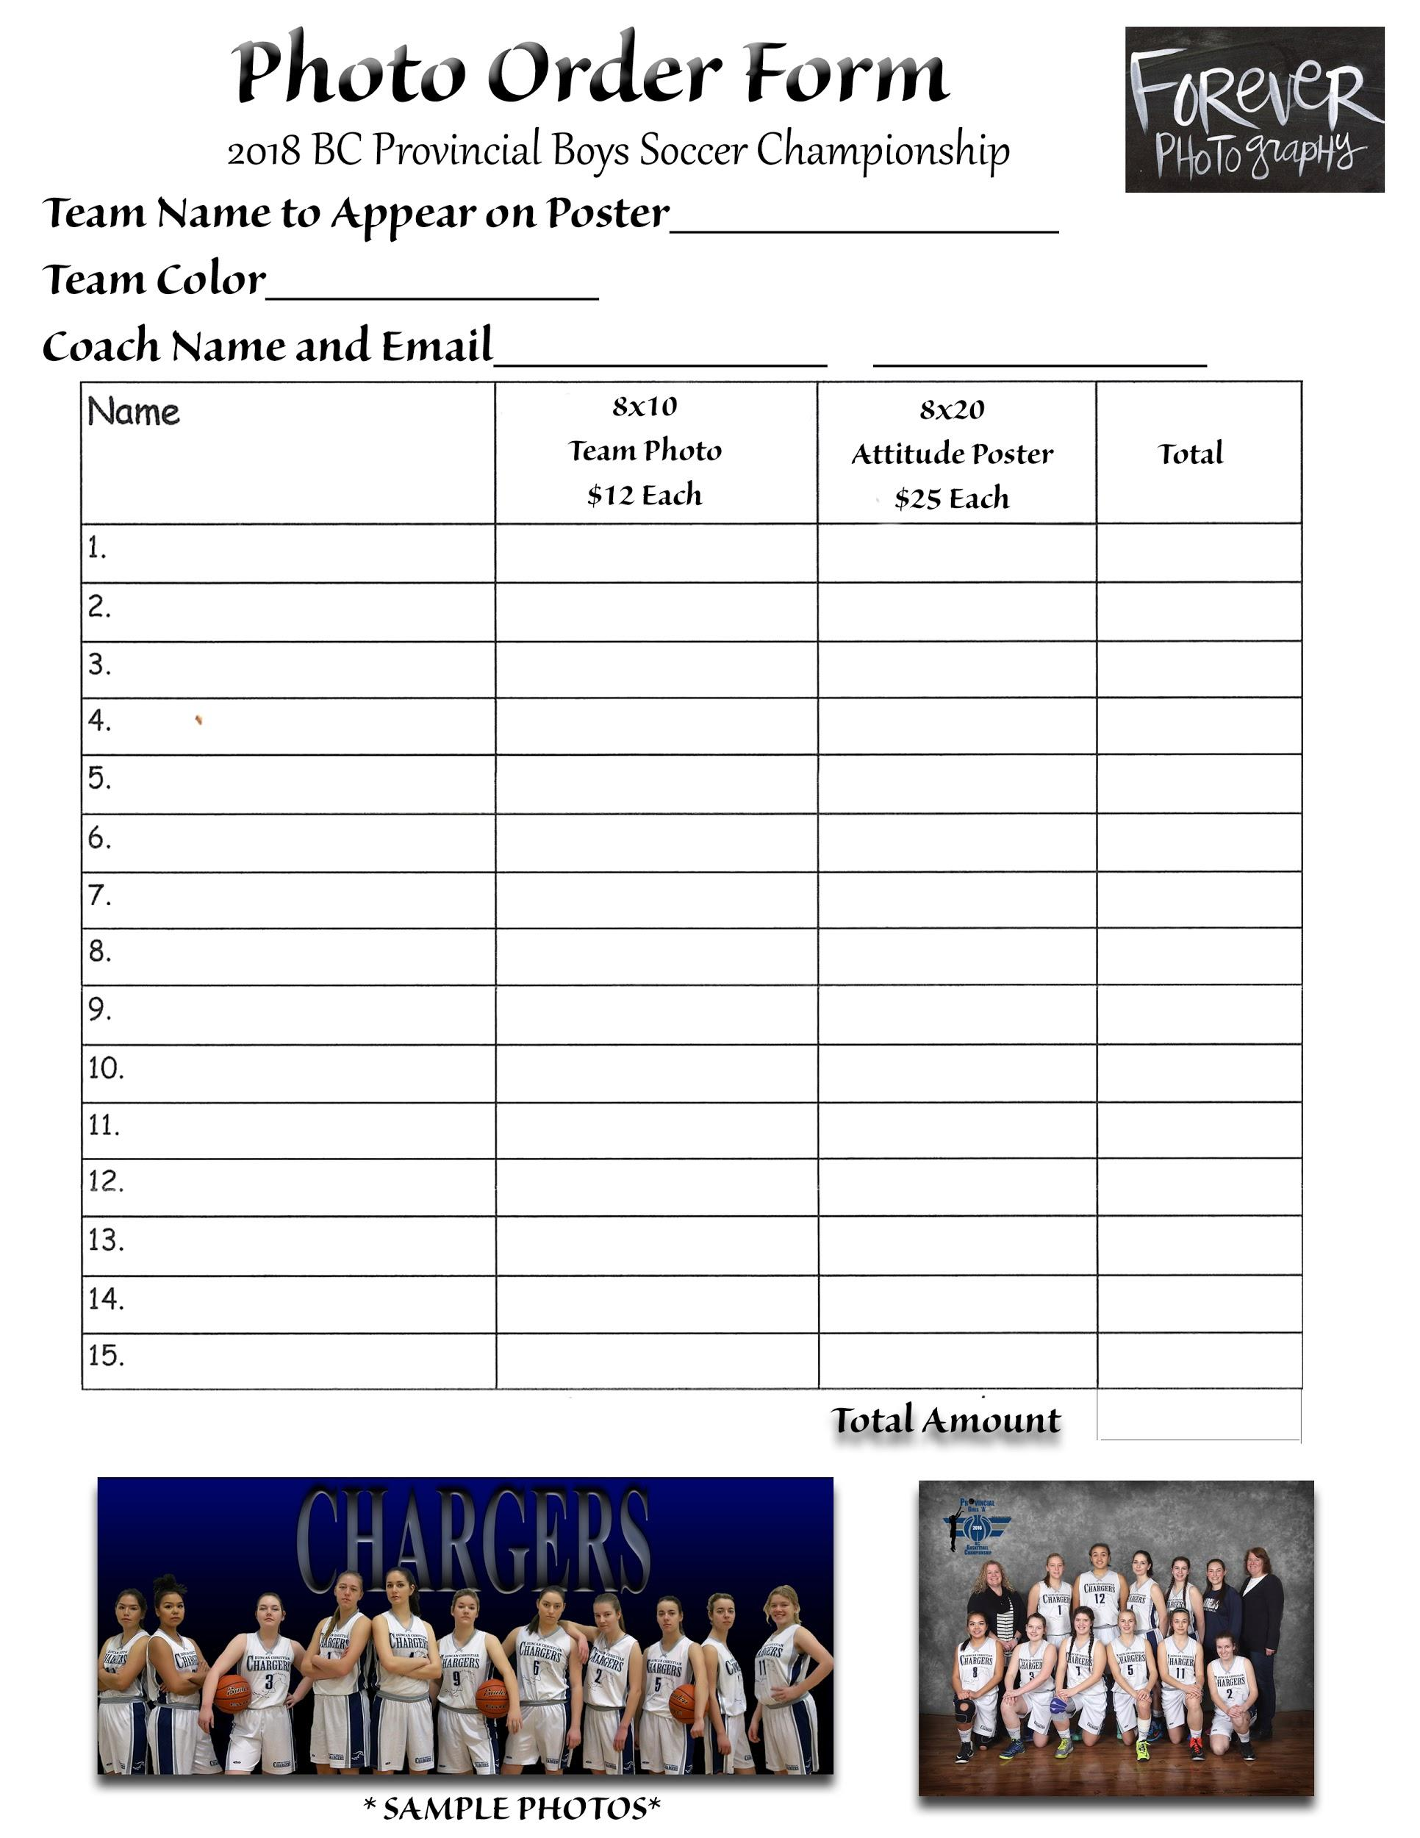
- Please print this form out and fill it in and then scan it back to tveenstra@dunchristian.com Thanks!

Venue Information

Cowichan Sportsplex  5847 Chesterfield Ave, Duncan, BC V9L 3M2 | McAdam Park  820 Wharncliffe Rd, Duncan, BC V9L 2K3
Rotary Park  545 Al Wilson Grove, Duncan, BC V9L 5E4 | Sherman Park  3272 Sherman Rd, Duncan, BC V9L 4B4
Evans Field #2
6257 Somenos Rd, Duncan, BC V9L 4G1

PLEASE NOTE: The COACHES MEETING will take place on the evening of Wed. Oct. 31 at 7:00 pm at Duncan Christian School 495 Beech Ave. Duncan, B.C.

Team photos(including Attitude Poster photos – if pre-ordered):
ALL TEAM PHOTOS will be TAKEN on Thursday, Nov. 1

9:00 am - 10:30 am For teams NOT Playing in the 9:00 am games

11:30 am - 12:15 pm For teams that played in the 9:00 am games

* Please make sure your team is available in FULL UNIFORM.

Tournament Coordinator Contact

Tom Veenstra can be reached for any tournament details, questions or concerns via phone or text at the following number: 250- 510-7311

Provincials Media and Updates
Provincial Boys A Soccer Website = www.soccer2018.ca/

School website - www.duncanchristianschool.ca

Accommodations

https://www.soccer2018.ca/accommodations

2018 Boys “A” Soccer Provincial Timeline
Wednesday,Oct. 31
Coaches Meeting - 7:00 pm
Registration
- email package ahead of time to tveenstra@duncanchristian.com
- you will pick up: clothing orders, banquet tickets ($25 each), and other information we have for you
- you will drop off: tournament fee ($485), payment for clothing and photos and banquet tickets

Thursday,November 1
Team photos:

ALL TEAM PHOTOS will be TAKEN
9:00 am - 10:30 am For teams NOT Playing in the 9:00 am games

11:30 am - 12:15 pm For teams that played in the 9:00 am games

* Please make sure your team is available in FULL UNIFORM.Thank you very much for your help with this!

Games
- when the game is finished, teams need to line up across from each other at center
- Player of the Game will be awarded to each team as chosen by the Coach of the opposing team in Consultation with the Coach of the team.
- Game results will be posted on the website. Coaches are responsible for reading the draw and knowing when they play next.
- Please note: Duncan Christian will always play at the Cowichan Sportsplex. Where Duncan Christian is scheduled to play, the teams playing at the Sportsplex will switch and play at the site that Duncan Christian was schedule to play.

Thursday,November 1

Banquet
- tickets are available for players and coaching staff. Unfortunately there is not enough room for parents, siblings etc.
- Location: RAMADA (Silver Bridge Inn), Duncan 140 Trans-Canada Hwy, Duncan, BC V9L 3P7
- tables will be designated for teams. Sit only in your spot as we have calculated how many on each team and how many at each table.
- Please arrive for 6 pm
- Dinner served at 6:30 pm

Contacts
Name
Tom Veenstra | Tournament Director | 250-510-7311 | tveenstra@duncanchristian.com

2018 Boys Soccer Championships

2018 Media Information Sheet

School Name: A, AA or AAA

City/Town:

Coach:

Listed below are the local media from your area where results can be sent. The Championship Organizing Committees will endeavor to send the results to the media identified below. Please type in email addresses.

Media Name Media Contact Name Email Address

FORMS MUST BE RECEIVED BY
3:00 pm on Tues. Oct. 23
Email to Tom Veenstra tveenstra@duncanchristian.com as well as brought to the Coaches Meeting

2018 Boys Soccer Championships

2018 Uniform Colour Information Sheet

School Name:

Coach:

Listed below the uniform colours according to First Choice followed by Second Choice. Schools need to have two different coloured sets of jerseys (and preferably socks)

First Choice

Tops

Shorts

Socks

Second Choice

Tops

Shorts

Socks

FORMS MUST BE RECEIVED BY
October 23, 2018
Email to Don Moslin dmoslin@sd68.bc.ca and Tom Veenstra tveenstra@duncanchristian.com

2018 BC Secondary School Girls Soccer Championships

The Organizing Committee has requested this year that your school designate the adult individual from your school who is responsible for all players, coaches, and parents while at the 2018 BC Secondary School Soccer Championships. The Organizing Committee further requests that all players be supervised while at the facilities of Duncan Christian School and at the Championship sites and its events.

Please return this completed form below to the Organizing Committee Member – Tom Veenstra at the appropriate Coaches Meeting.

School

Designated Person:

Administrative Officer Signature:

Coaches Checklist

Please submit the following by 3:00 pm on Tues. Oct. 23
- Team Photo by standards listed earlier in this document
- Team Roster by standards listed above
- Team Clothing and Tournament Expenses Form (includes banquet fees, tournament registration fee, total clothing, program and photo fees
- Scanned copy of Completed Team Photo and Team Attitude form
- Your school’s athletic logo
- School Name:
- Athletic Director Name:
- Athletic Director email:
- Coaches name(s):
- Coaches email
- Coaches phone number (Cell #):
- Uniform Colour information sheet: Primary shirt, short and sock colours form
- Designated Adult form indicating who will be responsible for your team
- Media sheet
- Program order form
- Banquet ticket form

Secondary School Soccer Championship Rules
Boys and Girls Soccer

Format

- Sixteen teams have been divided into four groups of four teams each A, B, C, and D.

- Each group will play a single round robin within their group then proceed to further play according to placing.

  - Games to be 2 x 35 minute halves.
  - 3 points for a win.
  - 0 points for a loss.
  - 1 point for a tie.

- Game Tie Breaking Procedure

    - In all round robin games, if a tie results at the end of regulation time, each team receives 1 point.

    - In all other games after round robin play if a tie results at the end of regulation time a (2 x 7 ½ minute) overtime will be played. NO GOLDEN GOAL will be used. If the game is still tied then penalty shots will be taken (F.I.F.A. rules). Games on the final day of the Championships to place schools from 5th to 16th will not have overtime and will go straight to penalty shots (shots from the mark).

- Group tie breaking procedure

Round Robin Tie Breaker Rules

Two teams tied

- Previous Match Result
The winner of the match between two teams tied in points shall be awarded the higher position.

If two teams tied their game during round robin play then the next procedure is to go to b)

- Penalty Kicks
These kicks will be taken after round robin play. F.I.F.A. rules

Three or Four teams tied

***Only the games between the tied teams will be used***. This process will be used in its entirety, if needed, to place the teams following round robin play.

- Goal Difference
Goal difference shall be calculated by subtracting Goals conceded from Goals scored. A maximum of five (5) goals shall be awarded in each game. (Example: a 5 – 0 score (5 goal difference), a 7 – 1 score (5 goal difference), a 7 – 3 score (4 goal difference).
- Least Goals Against
The team having the fewer number of goals against will be awarded the higher position.

- Penalty Kicks
If two or more teams are still tied under criteria (a) – (b), then the higher standings shall be decided by kicks from the penalty spot, as follows:

*Three teams tied:
Each team is designated A or , B, or C. Three mini-games shall be played (A vs B, B vs C, C vs A) consisting of five (5) penalty kicks at a time and place to be decided by the Commission Representative.

*Four teams tied
Each team is designated A, B, C, or D. Six mini-games shall be played (A vs B, C vs D, A vs C, B vs D, D vs A, and C vs B), to decide the final ranking as in the three team case.

The standings after these three/four mini-games shall be ranked. All five shots are to be taken in each mini-game regardless of the score. The total goals scored in the mini-game will be used to decide placement.

Rules

- No team may dress more than 20 players for any game.

- Substitutes may be unlimited.

- Coaches must submit their team list to the referee or field coordinator before each
game indicating the name and number of each player.

- Scores will be validated and recorded by the referee.

- All rules as outlined by the BC SCHOOL SPORTS handbook will be upheld.

- All decisions of the referee are final. Other rule violations should be brought to
the attention of the coordinator.

- Any player receiving 3 yellow cards during the tournament must sit out the
following game. Additional games may be given by the Discipline Committee.

- Any player receiving a red card is automatically suspended from further
participation in the tournament subject to a hearing of the Discipline Committee. Additional games may be given.

- Protest and player misconduct will be dealt with by the Discipline Committee.

i. A team wishing to protest must do so within 30 minutes of the completion of the game along with a $250.00 protest fee. In the event that a protest is upheld by the Commission, the protest fee shall be refunded. In the event that the protest is denied, the protest fee shall be retained.

ii. The grounds upon which the protest is based must be included in a written submission. An individual or team planning to file a protest must inform BC Secondary Schools Soccer personnel or the Championship Organizing Committee at the Soccer headquarters within thirty minutes of the completion of the game. Following this, the full protest submission and the accompanying fee must be submitted within one (1) hour of the completion of the game. The fee must accompany the protest.

iii. The protest must contain the details of the protest, including the rule that was allegedly breached, and the evidence to support that claim. Protests can only be considered on the grounds of misinterpretation of FIFA Laws of the Game, on the eligibility of players, or on breaches of the Competition Rules and Regulations

iv. In dealing with any protest, the association having jurisdiction may take into consideration the possession by the protesting team of any prior knowledge, which, if properly used, might have obviated the protest.

v. Any team playing an ineligible player shall forfeit the game to its opponents, provided the protest is upheld.

vi. A copy of the protest shall be forwarded by the Commission to the opposing team as soon as possible days after the receipt of the protest. Upon receipt of the protest the opposing team shall have a maximum of 1 hour to supply a response to BC Secondary Schools Soccer personnel or the Championship Organizing Committee at the Soccer headquarters, failing which BC Secondary schools Soccer Commission may render its decision based solely on the information provided by the protesting team.

vii. The protest shall be signed by the team coach or manager, club or member organization official.

viii. The fee is payable to the BC Secondary Schools Soccer Commission shall be determined and circulated by the Commission

ix. BC Secondary Schools Soccer Commission is required to provide to all parties affected by a decision, a written ruling which shall include the rationale for the decision and the associations appeal procedures, within five (5) working days of notification of the opposing team.

- Appeals to decisions made by the Discipline Committee are made to the Appeals
Committee. There will be a $250.00 fee to appeal a decision made by the Discipline Committee and must accompany the Appeal. The Appeal must state concisely the grounds for the appeal. The appeals must be completed within the timeline indicated on the decision being appealed or indicated at the appropriate Coaches Meeting.

- Teams are request to sit on opposite sides of the field unless there is a fourth official or it permanent benches are present and then will be placed on the same side of the field .

BC SECONDARY SCHOOLS SOCCER MATCH SHEET Male

Female

Game | Date | Time | Venue

Home Team | FINAL SCORE | Visiting Team | FINALSCORE
Uniform Colours |  | Uniform Colours

Team List of:

Uniform  Number | Name  Last | Name  First | Goals | Discipline

Coach

Match Officials Referee

Assistant Referee #1 Assistant Referee #2

21 THINGS TO DO IN THE COWICHAN VALLEY (winter)

1. Visit the Cowichan Regional Visitor Centre- Drop in to say hello to our friendly and knowledgeable staff. We’ll share up to date information on local community events, dining, attractions and accommodation. Our wide selection of tourist information covers all regions of British Columbia. We are located at 2896 Drinkwater Rd (adjacent to the BC Forest Discovery Centre).

2. Visit the Cowichan Valley Museum – Located in downtown Duncan by the railway station this unique, interactive museum features a recreated pioneer store, hospital wing and a special look into the history behind the famous Cowichan Sweater. A must for history buffs.

3. Visit the Local Art Galleries – Spend a day with a friend or just go by yourself and peruse the numerous galleries and studios found in the Cowichan Valley. You can choose to visit the artists’ home studios or the downtown Duncan ones. There’s sure to be something appealing for every art lover! Studio tour maps available at the Cowichan Regional Visitor Centre

4. Take a Totem Tour – The self-guided tours take visitors through downtown Duncan to view the famous totems using a map available at the Visitor Centre. Follow the yellow footprints painted on the sidewalks. The visitor center also sells a newly updated totem tour guide book.

5. Walk the Trans-Canada Trail – Visit the Kinsol Trestle -Enjoy the outdoors and hike the local area via the Trans-Canada Trail. Following the old “Galloping Goose Rail Line”, with eight historic trestle crossings, including the newly restored 90-year-old Kinsol Trestle, Cowichans 122 km trail section will delight nature and history enthusiasts alike.

6. Hike the Cowichan River Footpath – Start at either the Fish or Game Club in Glenora or at Skutz Falls. This rugged and magnificent 20 km hike is accessible to all. For more information, contact the Visitor Centre.

7. Enjoy the Outdoors – Explore the Cowichan Valley and experience spectacular views of our area after a hike up Mt. Tzhouhalem, Mt. Prevost, Maple or Cobble Hill Mountain. Visit the Visitor Centre for maps of local hiking trails. You can also golf all year round on most local golf courses.

8. Visit the Cowichan Aquatic Centre - with 2 large indoor pools, fitness centre, sauna and steam room.The center has great daily fitness programs and is open all year round.

9. View the World’s Largest Hockey Stick – Located on the east side of the Island Savings Community Centre on James Street, this world famous, 205-foot attraction was on display at the 1986 Expo in Vancouver. Make sure to bring your camera! World’s Largest Hockey Stick Souvenirs available at the Cowichan Regional Visitor Centre

10. Take an Agricultural Tour – Visit one of the many farms that make our valley unique, including lavender, tea, cranberry, Water Buffalo and organic produce. Many of these local products can be found at our Saturday Farmer’s Market!

11. Attend the Chemainus Theatre – Want to see quality professional theatre in a quaint small town setting? Then look no further than the Chemainus theatre, a majestic building housing as well as the theatre itself, and elegant (and delicious) dining room, and a gallery/gift shop. For more information and reservations, call 1-800-565-7738 or (250) 246-9820.

12. Enjoy Local Seafood – Treat yourself to fresh seafood from one of the local fish markets or check the government wharf at Cowichan Bay and buy fresh shrimp, prawns or crab right off the boat. Don’t feel like cooking? Perhaps you would like to try one of the succulent seafood restaurants overlooking the water. Nibble on smoked salmon while enjoying the sights of Cowichan Bay from the wharf.

13. Get up close with birds of prey, at Pacific Northwest Raptors – View the incredible flight skills of the raptors that live at Pacific Northwest Raptors. Watch an eagle as he soars overhead, witness a red-tailed hawk make the catch as he shows off his hunting skills, and feel the thrill of a falcon rushing past you in pursuit of his lunch!

14. Cowichan Bay with the Maritime Museum has many quaint stores. Take in the captivating history and view artifacts of maritime activity in Cowichan Bay. This village is the slow food capital of our island with great fish restaurants. You can admire the house boats and fishing boats on your walks by the wharf. Watch out for the seals!

15. Shop in Downtown Duncan – Picture yourself in a quaint old town with unique, one-of-a-kind shops lining the narrow streets, local restaurants and bakeries serve fresh and delicious food catering to every palette, and yellow painted footprints dot the sidewalks, guiding you through Duncan’s renowned totem tour.

16. Saturday Farmer’s Market - Duncan’s market is home to more than 100 vendors…and growing! Spilling over City Square, Craig & Ingram Streets, enjoy local crafts, fresh produce, arts, food sampling, garden items, wine tasting and entertainment from 9am-2pm.

17. Enjoy a Theatrical Performance at the Cowichan Theatre – Ranging from High school plays and musicals to professionals from afar, you are sure to find a play to see. For more information contact the Centre Theatre box office at 748-7529.

18. View Old Churches – The Cowichan Valley is home to some beautiful religious architecture. A pleasant drive through the countryside will take you to several including Cowichan Station, St Ann’s on Tzouhalem Rd, and St Peter’s.

19. Somenos Marsh – Catch some tranquil moments viewing inhabitants of the Somenos Marsh. This wildlife sanctuary, which lies east of the Trans Canada Highway, offers a quiet refuge for a variety of birds and animals.

20. Whippletree Junction Artists’ Market- Come and visit these old heritage buildings from the past, which now have quaint stores and artist galleries.

21. Take a Winery Tour – Sample some of the Cowichan Valley’s award winning wines and ciders while traveling through the picturesque farmland of the valley. Enjoy wine tastings, tours, galleries, gift shops and restaurants. For local winery locations and hours contact the Visitor Centre. Guided Wine tours available

~After all this you may be too tired to leave, so consider spending a night…or two… or three with us.~
From provincial campgrounds to quaint B&B’s and luxury hotels, we’ll find the right accommodation to suit your needs!

This information has been put together by the staff and volunteers of the
Cowichan Regional Visitor Centre Phone 250 746 4636 visitorinfo@duncancc.bc.ca
September 2015

Favorite Hikes in Cowichan Valley
Please be aware that many of these trails are also enjoyed by mountain bikers & equestrians
1. Maple Mountain
Maple Mountain is located 5 km north east of Duncan. The trail is 5 km one way, elevation gain is 310m. Suitable for day hikes all year. North of Duncan turn east onto Herd Rd then left onto Osborne Bay Rd (to Crofton). Follow this to park entrance. Trail begins in the trees to the north of the parking area. Further North on Osborne Bay Rd there is access via Chilco Rd to two trails within proximity of Sansum Narrows & Saltspring Island and leading into Maple Bay. At the cross roads, the trail on the left follows closer to the ocean.
2. Mount Prevost
Mount Prevost is a mountainous landmark towering over the city of Duncan easily identified by the two humps sitting on its peak. Travelling north on Hwy #1 through the city of Duncan, turn west onto Hwy #18 and continue traveling for 1.4 kilometres until you reach Somenos Rd. Turn North, drive 2 km to Mt. Prevost Rd. The Mt. Prevost Main Rd is sometimes closed to vehicular traffic due to active logging or fire hazard. When open, there are two parking areas near the peak - one on the east side is relatively close to the monument while the one towards the south is used by the hang-gliders to access their jumping-off point. Some of the activities enjoyed on Mt. Prevost include mountain biking, hiking, hang gliding and sightseeing.
3. Mt Tzouhalem
Suitable all year hike. From Hwy #1 Duncan turn east onto Trunk Rd. At the traffic circle follow signage to Maple Bay Rd. Follow Maple Bay Rd 3 kilometres, turn right onto Kingsview Rd and follow it up to Chippewa Rd (note Tzouhalem parking sign) to the Mt Tzouhalem Ecological Reserve. Turn right onto Chippewa and follow it to Kaspa Rd. Turn left onto Kaspa and follow it past yellow gate to the parking area. This is where the trail starts. To access the wildflower area and kiosk follow the trail leading off the west side of the parking area. The trail begins to climb gently to kiosk. Dogs are permitted on leash. Please do not disturb the plants.
A short hike concluding with a steeper trail section will bring you to a wonderful view of the Cowichan Valley.
4. Kinsol Trestle
The Kinsol Trestle is one of the tallest free standing timber rail trestle structures in the world. Offering breathtaking views of the Koksilah river and access to hiking trails. The re-constructed trestle opened July 2011 linking the Cowichan Valley Portion of the Trans Canada Trail. Amenities include ample parking on both sides as well as picnic tables, benches and toilets. Accessible to wheelchairs and strollers.
Directions to North End of Kinsol Trestle: From Hwy #1 south of Duncan turn west onto Koksilah Rd. After crossing the single lane Koksilah River Bridge, take a left on Riverside Rd. Follow this road (paved/gravel) for 8.5 km. Parking available. It is a five-minute walk to the north end of the Trestle.
Directions to South End of Kinsol Trestle: From Hwy #1, take one of the roads to the Village of Shawnigan Lake. Once there, follow Renfrew Rd westbound. Turn right onto Glen Eagles Rd, then right onto Shelby Rd. Parking area on the left. Follow the level, well-marked trail about 1.5km to the Kinsol Trestle.
5. Cowichan River Footpath
This trail stretching from Glenora Trailhead Park west to Skutz Falls is 20 km one way. Backpack or Day Hike suitable all year.
Access: Glenora Trailhead Park, From Hwy #1 (Duncan), turn west onto Trunk R. Left onto Allenby Rd, over the bridge and right onto Indian Rd. Right onto Glenora Rd. Right onto Vaux Rd (turns into Robertson Rd) for approx 6km. The staging area is located on the left near Cowichan River Provincial Park.
Skutz Falls trailhead: North of Duncan travel west on Hwy #18 18.7 km until you come to the turnoff to Skutz Falls. Turn left, follow the gravel road about 3 km to the falls. Access the trail on the far side of the river across the truck bridge. The best loop hikes are from this trailhead. This requires transportation at both ends if doing full trail. There are also a variety of walks that can be taken from each trailhead.

6. The Cowichan Valley Trail
This portion of the Trans Canada Trail travels north from south Shawnigan Lake, over the Kinsol Trestle and west to Lake Cowichan then continues back to Duncan and Northbound along the Hwy #18. It is 122 km long and connects to the Trans Canada trail. Other access points:
a) From the city of Duncan head north on Canada Ave travel west on Sherman Rd to Lane Rd where there is a trailhead. The trail continues towards Lake Cowichan. There are other access points west along Sherman Rd.
b) Lake Cowichan Staging Area: From Hwy #1, turn west onto Hwy #18, follow into Town of Lake Cowichan (Hwy becomes South Shore Rd), left on King George, right on Wellington, Look for trail info on right & trailhead kiosk on left.
c) Sooke Lake Rd Staging Area: From Hwy #1, turn onto S. Shawnigan Lake Rd, left onto Sooke Lake Rd. The Staging Area is located on the right, approximately two minutes down the road by car.
d) Glenora Trailhead Park: From Hwy #1, turn west onto Trunk R, left onto Allenby Rd (becomes Indian Rd, right onto Glenora Rd, right onto Vaux Rd (becomes Robertson Rd).
7. Somenos Dike Trail
Accessible from various locations. Access the north end of the trail at the Somenos Marsh Outdoor Classroom
(off Hwy #1 north of Beverly St). The trail heads south then east following Beverly St turns south at Lakes Rd connecting with Al Wilson Grove Rotary Park (accessed off McKinstry Rd). Parking available at both trail ends.
8. Chemainus Lake Trailhead:
From Hwy #1 (Chemainus) turn West onto River Rd, follow the road about 2 minutes, the parking lot will be on your right. Access restrictions: Dawn to dusk. This lovely, 3km loop is a pleasant stop off when driving up or down island. The trail circumnavigates Chemainus Lake with views across the lake to Mt Brenton.
9. Cobble Hill Mountain
Cobble Hill Mountain Regional Recreation Area is a popular destination for hiking, horseback riding, and mountain biking. The recreation area is made up of old logging roads, as well as signed trails. The entry point to Cobble Hill Mountain is through Quarry Nature Park. Amenities include picnic area, washrooms & parking.
Access: West off Hwy #1 onto Shawnigan Lake-Cobble Hill Rd, turn onto Empress Ave into Quarry Nature Park.
10. Mesachie Mountain
Follow signs from Town of Lake Cowichan to Mesachie Lake Village, about 6 km (4 miles). Turn right onto Forestry Rd. Go through village, turn right and park on the flat. Continue along Forestry Rd, cross bridge. The trail to Mesachie Mountain is to the right, past the barrier and following the wire fence; then NE through second-growth timber. Follow this until you come to a T junction, turn right onto the mountain trail. The upper part is one mossy hill. It is about one hour’s stroll from the barrier to the top, the view is excellent.
11. Holland Creek Trail
The forested loop of Holland Creek Trail runs for 6.4km/4mi from the craggy heights above Ladysmith on a south easterly course to an estuary at the ocean's edge. Park at access points and tackle all or part of the Holland Creek Trail. For a pleasant hour-long walk park at Methuen St and 6th Ave, hike the “upper loop” trail that takes in a waterfall, a pair of colliery dams (built in the early 1900s for the coal mining industry) and the Rotary Look-Out Trail (which leads to a scenic view picnic area). The parking lot on Mackie Rd off Malone Rd also offers easy access to the trail for those wanting a short walk to the scenic waterfall.
Heart Lake
Hike along Holland Creek behind Ladysmith then up a very steep but short section to Heart Lake. The trail is 6.4 km from the head of the Holland Creek Trail bridge. Those wanting a longer hike can continue on to Stocking Lake for a 9.3 km hike. The trail includes three levels: difficult, moderate and mild
Access: From Hwy 1 (Ladysmith), travel west up Roberts St., turn left onto 6th Ave.-parking will be on the right.

Created by the staff & volunteers of the Cowichan Regional Visitor Centre
Phone 250 746 4636 visitorinfo@duncancc.bc.ca
January 2016

